How to prepare for Sunday EasyWorship
Step 1 - Select EWS_Weekly_Download from Start menu
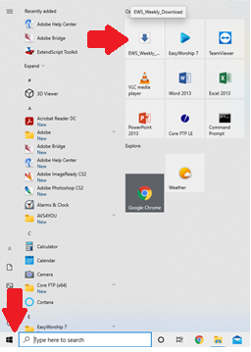
This will start a process to copy weekly files from ftp.oakriverchruch.com
Once the process completes, “Press any key to continue …. “ and move on to step 2
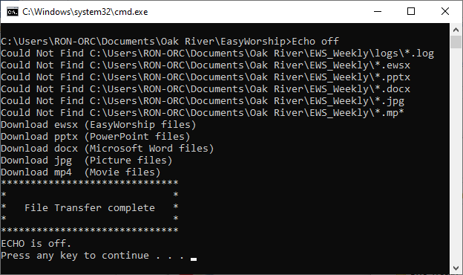

Step 2 – Select This PC > Documents > Oak River > EWS_Weekly
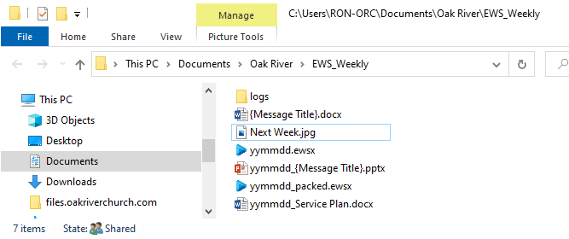

Step 4: Message PowerPoint
Step 5: Easyworship Schedule

Step 3: Service Plan

Step 3 – Open the current week’s Service Plan (Example: 210704_Service Plan.docx) and review schedule outline
NOTE: This step is optional if Service Plans has been communicated earlier
Step 4 – Open the current week’s PowerPoint file by double clicking on it (Example: 210704_{Message Title}.pptx)
This step helps assure PowerPoint loads the thumb nails, launches more quickly and runs smoothly
Minimize the PowerPoint, but DO NOT CLOSE THE FILE
Step 5 – Open the current week’s EasyWorship Schedule file by double clicking on it (Example: 210704_packed.pptx)
The packed file has all necessary media included, the other one is just the schedule and relies on the database
Step 6 – Confirm all parts of schedule run correctly (make any adjustments as required)
NOTE: If message thumbnails are black, right click on it in the schedule and choose Refresh Thumbnails
Step 7 – Communicate any out of ordinary schedule changes to Sound Technicians
FOLLOW THE SPIRIT’s LEADING - SMILE – HAVE FUN

